

**Universal Characteristic Method of Human Profiling**

**(毕达哥拉斯性格发展理论)**

原型指南表

**健康、事业、财富、人际关系和家庭成功**

###### 姓名 :

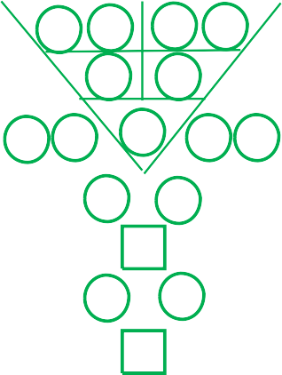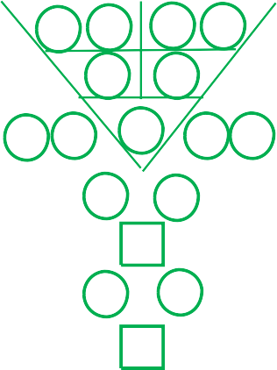

**{q} {first_name} {last_name}**

**生日日期** : **{d1} {d2}** - **{mm}** - **{y1} {y2} {y3} {y4}**

**生日时间** : **{t1} {t2} : {t3} {t4}**

**性别** :

**双胞胎或多胞胎** :

**{gender}**

**{twintrip}**

**编制人** : **{user}**

**日期** : **{pd1} – {pm1} – {yy}**

|  |  |  |  |  |
| --- | --- | --- | --- | --- |
|  |  |  |  |  |

## 原型指南表

{t3r}

{r3l}

|  |  |  |  |  |  |  |  |  |  |
| --- | --- | --- | --- | --- | --- | --- | --- | --- | --- |
| {d1} | {d2} | {mm} | | | {y1} | | {y2} | {y3} | {y4} |
|  | | | | | | | | | |
|  | {r11} | | {r12} |  | | {r13} | {r14} | |  |
|  |  | | {r21} |  | | {r22} |  | |  |
| {r31} | {r32} | |  | {r33} | |  | {r34} | | {r35} |
| {r41} | | | |  | | {r42} | | | |
|  | | | | {r51} | |  | | | |
| {r61} | | | |  | | {r62} | | | |
|  | | | | {r71} | |  | | | |

{r3r}

{t3l}

|  |  |  |  |  |  |  |  |  |  |
| --- | --- | --- | --- | --- | --- | --- | --- | --- | --- |
| {d1} | {d2} | {mm} | | | {t1} {t2} | | | {t3} | {t4} |
|  | | | | | | | | | |
|  | {t11} | | {t12} |  | | {t13} | {t14} | |  |
|  |  | | {t21} |  | | {t22} |  | |  |
| {t31} | {t32} | |  | {t33} | |  | {t34} | | {t35} |
| {t41} | | | |  | | {t42} | | | |
|  | | | | {t51} | |  | | | |
| {t61} | | | |  | | {t62} | | | |
|  | | | | {t71} | |  | | | |

数运数字

|  |
| --- |
| **{r11} {r12} {r13} {r14}** |
| **{r33}** |
| **{r22}** |
| **{r21}** |
| **{r34} {r35}** |
| **{r31} {r32}** |
| **{hpi}** |
| **{hpb}** |
| **{ht1} {ht2} {ht3} {ht4} {ht5}** |
| **{lc1} {lc2} {lc3} {lc4}** |

原型天性数字  
优点个性数字  
弱点个性数字 天生优势数字

毕生挑战数字 隐藏的潜能 - 直觉  
隐藏的潜能 - 盲点 隐藏的天赋

天性密码

|  |  |  |  |  |  |  |  |  |  |  |  |  |  |  |  |  |  |
| --- | --- | --- | --- | --- | --- | --- | --- | --- | --- | --- | --- | --- | --- | --- | --- | --- | --- |
|  | **49步自我了解** | | | | | | | | | | | | | | | |  |
|  | | | | | | | | | | | | | | | |
|  | 1 | **{r33}** | 8 | **{r14} {r22}** | 15 | **{r33} {r42}** | 22 | **{r12} {r21}** | 29 | **{r33} {r34}** | 36 | **{s} {r13}** | 43 | **{r14} {r33}** |  |
| 2 | **{r11} {r12}** | 9 | **{r22}** | 16 | **{r13} {r22}** | 23 | **{r21} {r32}** | 30 | **{r14} {r21}** | 37 | **{r11} {r33}** | 44 | **{r51} {r61}** |
| 3 | **{r13} {r14}** | 10 | **{r22} {r33}** | 17 | **{r22} {r34}** | 24 | **{r21} {r31}** | 31 | **{r22} {r31}** | 38 | **{r11} {r22}** | 45 | **{r51} {r62}** |
| 4 | **{r21} {r22}** | 11 | **{r33} {r41}** | 18 | **{r22} {r35} {r13}** | 25 | **{r32} {r41}** | 32 | **{r35} {r41}** | 39 | **{r12} {r22}** | 46 | **{r61} {r71}** |
| 5 | **{r31} {r32}** | 12 | **{r11} {r21}** | 19 | **{r34} {r42}** | 26 | **{r31} {r41}** | 33 | **{r11} {r13}** | 40 | **{r12} {r33}** | 47 | **{r62} {r71}** |
| 6 | **{r34} {r35}** | 13 | **{r21}** | 20 | **{r35} {r42}** | 27 | **{r41} {r51}** | 34 | **{r11} {r14}** | 41 | **{r13} {r21}** | 48 | **{r33} {r51}** |
| 7 | **{r41} {r42}** | 14 | **{r21} {r33}** | 21 | **{r42} {r51}** | 28 | **{r32} {r33}** | 35 | **{r12} {s}** | 42 | **{r13} {r33}** | 49 | **{r51} {r71}** |
|  | | | | | | | | | | | | | | | |

**关于{first_name} {last_name}**



**亲爱的 {first_name} {last_name}**

{r33}

###### 认识你自己，是人生智慧的开端！

###### 你是个 : {ucInfo1}

{ucInfo2}

**通过人际交往行为来判定，你归类为 : {rval} 和 {qval}**

{ucInfo3}

**你是一个 : {describe}**

{ucInfo4}

###### 你隐藏的潜能“盲点”:

###### {hiddenPotentialBlindSpot}

###### 你隐藏的潜能“直觉” :

{hiddenPotentialIntuition}



|  |  |  |  |
| --- | --- | --- | --- |
| **{first_name} {last_name}缺数或过多数字的含义** | | | |
| **号码** | **说明** | **数量** | **状况** |
| 1 | 领导素质，独立，影响力，魅力，创新能力，人际交往能力。 | **{icr1} ( {icq1} )** | **{ics1}** |
| 2 | 交际能力，谈判能力。 | **{icr2} ( {icq2} )** | **{ics2}** |
| 3 | 积极进取，任务导向，倾听，操作能力。 | **{icr3} ( {icq3} )** | **{ics3}** |
| 4 | 策略，行政处理，尽职尽责，奉公守法。 | **{icr4} ( {icq4} )** | **{ics4}** |
| 5 | 方向感，建设性，建立想法和概念， 原则， 脚踏实地。 | **{icr5} ( {icq5} )** | **{ics5}** |
| 6 | 家庭导向，保护者，影响力， 魅力， 人际交往能力。 | **{icr6} ( {icq6} )** | **{ics6}** |
| 7 | 幸运、进取心、支配、多任务并行处理能力、解决问题、谈判能力。 | **{icr7} ( {icq7} )** | **{ics7}** |
| 8 | 幸存者、负责任、判断能力、自律能力、工作狂。 | **{icr8} ( {icq8} )** | **{ics8}** |
| 9 | 创意，远见，商业头脑，包装能力。 | **{icr9} ( {icq9} )** | **{ics9}** |
|  | | | |

**{first_name} {last_name} 支持和控制图表  
(综合 PCDT, NLP, DISC-O and EQ)**

**颜色**

**EQ**

**DISC-O**



**NLP**

**形状**

**选择 原型天性数字**

**感官**

听

（耳）



#### 3 & 8

红、橙、紫、粉红

听觉

(O)操作型

自我激励

**第一选择  
 你控制**



关系管理

社会意识

自我管理

自我意识

嗅觉

(S) 稳定型

(C) 服从型

(D) 支配型

(I) 影响型

视觉

味觉

触觉

黑、蓝

金、银、白

说

（口）

触

（手）

1 & 6

**第二选择  
 支持你**

**第三选择  
 中立**

**第四选择  
 你支持**

**第五选择  
 控制你**



2 & 7

青

视

（眼）



#### 4 & 9

黄、棕、米黄

嗅

（鼻）



5

**{first_name} {last_name}天性密码的设计提议**





# {lc1} {lc2} {lc3} {lc4} {lc1} {lc2} {lc3} {lc4}

**{lc1} {lc2} {lc3} {lc4}**



|  |  |
| --- | --- |
| **{first_name} {last_name} 天性密码的设计提议** | |
| 3 & 8  **第一选择 你控制** | {pc1} |
| 1 & 6  **第二选择 支持你** | {pc2} |
| 2 & 7  **第三选择 中立** | {pc3} |
| 4 & 9  **第四选择**  **你支持** | {pc4} |
| 5  **第五选择 控制你** | {pc5} |
|  | |

潜在的遗传疾病

潜在的妇科病 / 男性疾病

Potential Heart Bypass : {pothb}

潜在的冠心病

潜在的心脏病

潜在的癌症

Potential Heart Attack : {potha}

|  |  |  |  |  |
| --- | --- | --- | --- | --- |
| **{first_name} {last_name} 健康检查** | | | | |
| **检验项目** | | **数量** | **状况** | |
| **肺** | 肺/大肠相关疾病、孤立、愤世嫉俗的态度、哮喘皮肤过敏、过敏性鼻炎。 | **{hpr1} ( {hpq1} )** | **{hps1}** | |
| **肾** | 肾脏/膀胱相关疾病、恐惧症、腰痛、坐骨神经痛尿频、黑眼圈/眼袋、中枢神经系统疾病、恶寒、怕冷  、阳痿/性冷感 | **{hpr2} ( {hpq2} )** | **{hps2}** | |
| **心脏** | 心脏/小肠相关疾病、心血管疾病、失眠、烦躁、 健忘、、过度兴奋/刺激、言语障碍、忧郁症、胸部疼痛、敏感。 | **{hpr3} ( {hpq3} )** | **{hps3}** | |
| **肝** | 肝脏及相关疾病、狂躁不安、沉默痴呆、忧郁、  急躁易怒、眼疾、平衡/协调问题、肌肉痉挛、缺乏灵活性/僵硬、口腔苦涩、月经不调、肌腱相关疾病。 | **{hpr4} ( {hpq4} )** | **{hps4}** | |
| **胃** | 胃/胰腺/脾脏相关疾病、免疫系统问题、消化问题  、暖气、打嗝、虚不受补、肥胖或过瘦、贫血症  、痔疮、便溏、大便稀烂、淋巴问题。 | **{hpr5} ( {hpq5} )** | **{hps5}** | |
|  | | | | {pothd} |
| {potp} |
|  |

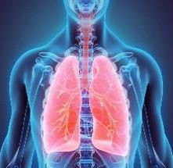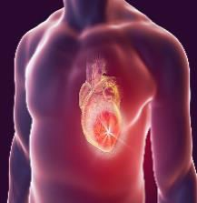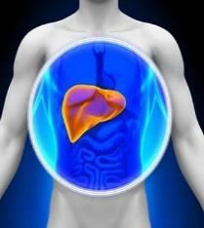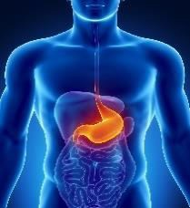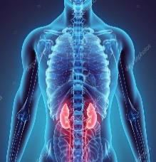

Potential Cancer : {potc}

#### Potential Hereditary Diseases :



Potential Cervical/Prostate Issue :

**{first_name} {last_name} 9年世界展望图表**

**{wy31} {wy32} {wy33} {wy34}**

**{wy21} {wy22} {wy23} {wy24}**

**年**

**年**

**年**

**{wy11} {wy12} {wy13} {wy14}**

{w33l}

{w3l}

{w3r}

{w23l}

{w23r}

{w33r}

|  |  |  |  |  |  |  |  |  |  |
| --- | --- | --- | --- | --- | --- | --- | --- | --- | --- |
|  | |  | | | {wy11} | | {wy12} | {wy13} | {wy14} |
| {d1} | {d2} | {mm} | | |  | | |  | |
|  | {w11} | | {w12} |  | | {w13} | {w14} | |  |
|  |  | | {w21} |  | | {w22} |  | |  |
| {w31} | {w32} | |  | {w33**}** | |  | {w34} | | {w35} |
| {w41} | | | |  | | {w42} | | | |
|  | | | | {w51} | |  | | | |
| {w61} | | | |  | | {w62} | | | |
|  | | | | {w71} | |  | | | |
|  | | | | | | | | | |

|  |  |  |  |  |  |  |  |  |  |
| --- | --- | --- | --- | --- | --- | --- | --- | --- | --- |
|  | |  | | | {wy21} | | {wy22} | {wy23} | {wy24} |
| {d1} | {d2} | {mm} | | |  | | |  | |
|  | {w211} | | {w212} |  | | {w213} | {w214} | |  |
|  |  | | {w221} |  | | {w222} |  | |  |
| {w231} | {w232} | |  | {w233} | |  | {w234} | | {w235} |
| {w241} | | | |  | | {w242} | | | |
|  | | | | {w251} | |  | | | |
| {w261} | | | |  | | {w262} | | | |
|  | | | | {w271} | |  | | | |
|  | | | | | | | | | |

|  |  |  |  |  |  |  |  |  |  |
| --- | --- | --- | --- | --- | --- | --- | --- | --- | --- |
|  | |  | | | {wy31} {wy32} | | | {wy33} | {wy34} |
| {d1} | {d2} | {mm} | | |  | | |  | |
|  | {w311} | | {w312} |  | | {w313} | {w314} | |  |
|  |  | | {w321} |  | | {w322} |  | |  |
| {w331} | {w332} | |  | {w333} | |  | {w334} | | {w335} |
|  |  | | {w341} |  | | {w342} |  | |  |
|  |  | |  | {w351} | |  |  | |  |
|  |  | | {w361} |  | | {w362} |  | |  |
|  |  | |  | {w371} | |  |  | |  |
|  | | | | | | | | | |

**{wy61} {wy62} {wy63} {wy64}**

**{wy51} {wy52} {wy53} {wy54}**

**年**

**年**

**年**

**{wy41} {wy42} {wy43} {wy44}**

{w63l}

{w43l}

{w43r}

{w53l}

{w53r}

{w63r}

|  |  |  |  |  |  |  |  |  |  |
| --- | --- | --- | --- | --- | --- | --- | --- | --- | --- |
|  | |  | | | {wy41} | | {wy42} | {wy43} | {wy44} |
| {d1} | {d2} | {mm} | | |  | | |  | |
|  | {w411} | | {w412} |  | | {w413} | {w414} | |  |
|  |  | | {w421} |  | | {w422} |  | |  |
| {w431} | {w432} | |  | {w433} | |  | {w434} | | {w435} |
| {w441} | | | |  | | {w442} | | | |
|  | | | | {w451} | |  | | | |
| {w461} | | | |  | | {w462} | | | |
|  | | | | {w471} | |  | | | |
|  | | | | | | | | | |

|  |  |  |  |  |  |  |  |  |  |
| --- | --- | --- | --- | --- | --- | --- | --- | --- | --- |
|  | |  | | | {wy51} | | {wy52} | {wy53} | {wy54} |
| {d1} | {d2} | {mm} | | |  | | |  | |
|  | {w511} | | {w512} |  | | {w513} | {w514} | |  |
|  |  | | {w521} |  | | {w522} |  | |  |
| {w531} | {w532} | |  | {w533} | |  | {w534} | | {w535} |
| {w541} | | | |  | | {w542} | | | |
|  | | | | {w551} | |  | | | |
| {w561} | | | |  | | {w562} | | | |
|  | | | | {w571} | |  | | | |
|  | | | | | | | | | |

|  |  |  |  |  |  |  |  |  |  |
| --- | --- | --- | --- | --- | --- | --- | --- | --- | --- |
|  | |  | | | {wy61} {wy62} | | | {wy63} | {wy64} |
| {d1} | {d2} | {mm} | | |  | | |  | |
|  | {w611} | | {w612} |  | | {w613} | {w614} | |  |
|  |  | | {w621} |  | | {w622} |  | |  |
| {w631} | {w632} | |  | {w633} | |  | {w634} | | {w635} |
|  |  | | {w641} |  | | {w642} |  | |  |
|  |  | |  | {w651} | |  |  | |  |
|  |  | | {w661} |  | | {w662} |  | |  |
|  |  | |  | {w671} | |  |  | |  |
|  | | | | | | | | | |

**{wy91} {wy92} {wy93} {wy94}**

**{wy81} {wy82} {wy83} {wy84}**

**年**

**年**

**年**

**{wy71} {wy72} {wy73} {wy74}**

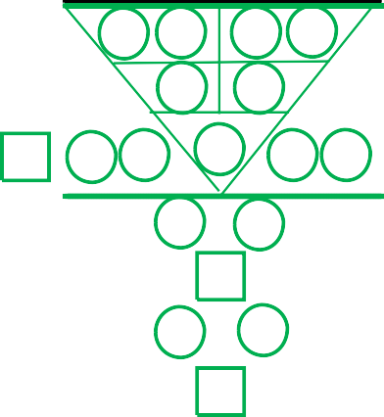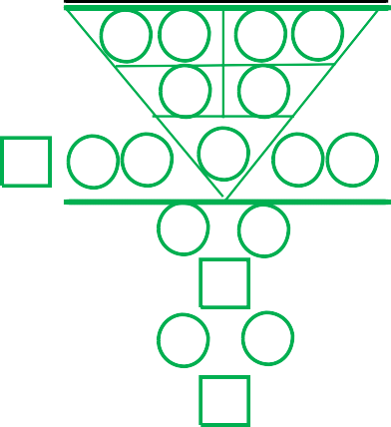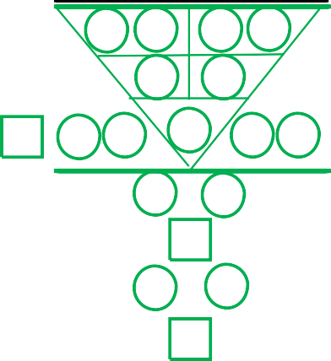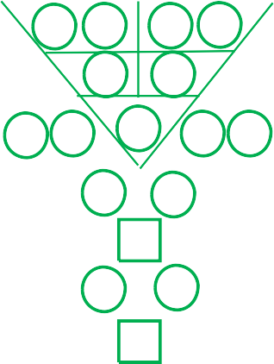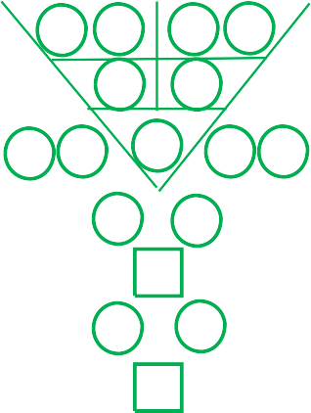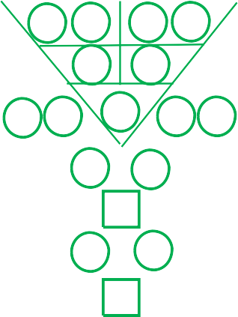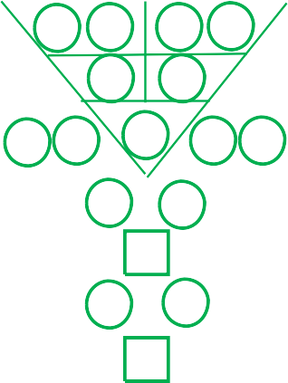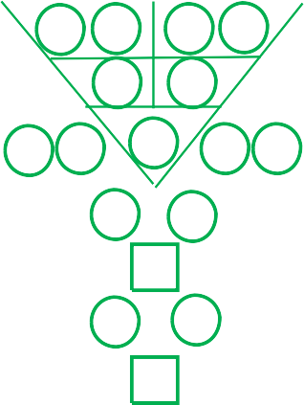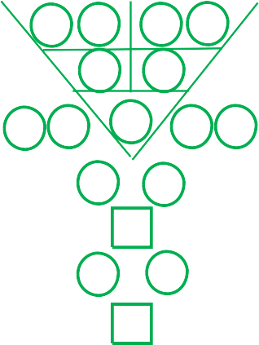

{w93l}

{w73l}

{w73r}

{w83l}

{w83r}

{w93r}

|  |  |  |  |  |  |  |  |  |  |
| --- | --- | --- | --- | --- | --- | --- | --- | --- | --- |
|  | |  | | | {wy71} | | {wy72} | {wy73} | {wy74} |
| {d1} | {d2} | {mm} | | |  | | |  | |
|  | {w711} | | {w712} |  | | {w713} | {w714} | |  |
|  |  | | {w721} |  | | {w722} |  | |  |
| {w731} | {w732} | |  | {w733} | |  | {w734} | | {w735} |
| {w741} | | | |  | | {w742} | | | |
|  | | | | {w751} | |  | | | |
| {w761} | | | |  | | {w762} | | | |
|  | | | | {w771} | |  | | | |
|  | | | | | | | | | |

|  |  |  |  |  |  |  |  |  |  |
| --- | --- | --- | --- | --- | --- | --- | --- | --- | --- |
|  | |  | | | {wy81} | | {wy82} | {wy83} | {wy84} |
| {d1} | {d2} | {mm} | | |  | | |  | |
|  | {w811} | | {w812} |  | | {w813} | {w814} | |  |
|  |  | | {w821} |  | | {w822} |  | |  |
| {w831} | {w832} | |  | {w833} | |  | {w834} | | {w835} |
| {w841} | | | |  | | {w842} | | | |
|  | | | | {w851} | |  | | | |
| {w861} | | | |  | | {w862} | | | |
|  | | | | {w871} | |  | | | |
|  | | | | | | | | | |

|  |  |  |  |  |  |  |  |  |  |
| --- | --- | --- | --- | --- | --- | --- | --- | --- | --- |
|  | |  | | | {wy91} {wy92} | | | {wy93} | {wy94} |
| {d1} | {d2} | {mm} | | |  | | |  | |
|  | {w911} | | {w912} |  | | {w913} | {w914} | |  |
|  |  | | {w921} |  | | {w922} |  | |  |
| {w931} | {w932} | |  | {w933} | |  | {w934} | | {w935} |
|  |  | | {w941} |  | | {w942} |  | |  |
|  |  | |  | {w951} | |  |  | |  |
|  |  | | {w961} |  | | {w962} |  | |  |
|  |  | |  | {w971} | |  |  | |  |
|  | | | | | | | | | |

**{first_name} {last_name} 2022 每月世界展望图表**

**年 年 年**

**3月和12月**

**{my11} {my12} {my13} {my14}**

**2月和11月**

**{my11} {my12} {my13} {my14}**

**{my11} {my12} {my13} {my14}**

**1月和10月**

|  |  |  |  |  |  |  |  |  |  |
| --- | --- | --- | --- | --- | --- | --- | --- | --- | --- |
|  | | 0 1 | | | {my11} | | {my12} | {my13} | {my14} |
| {d1} | {d2} | {mm} | | |  | | |  | |
|  | {m11} | | {m12} |  | | {m13} | {m14} | |  |
|  |  | | {m21} |  | | {m22} |  | |  |
| {m31} | {m32} | |  | {m33} | |  | {m34} | | {m35} |
| {m41} | | | |  | | {m42} | | | |
|  | | | | {m51} | |  | | | |
| {m61} | | | |  | | {m62} | | | |
|  | | | | {m71} | |  | | | |
|  | | | | | | | | | |

|  |  |  |  |  |  |  |  |  |  |
| --- | --- | --- | --- | --- | --- | --- | --- | --- | --- |
|  | | 0 2 | | | {my11} | | {my12} | {my13} | {my14} |
| {d1} | {d2} | {mm} | | |  | | |  | |
|  | {m211} | | {m212} |  | | {m213} | {m214} | |  |
|  |  | | {m221} |  | | {m222} |  | |  |
| {m231} | {m232} | |  | {m233} | |  | {m234} | | {m235} |
| {m241} | | | |  | | {m242} | | | |
|  | | | | {m251} | |  | | | |
| {m261} | | | |  | | {m262} | | | |
|  | | | | {m271} | |  | | | |
|  | | | | | | | | | |

|  |  |  |  |  |  |  |  |  |  |
| --- | --- | --- | --- | --- | --- | --- | --- | --- | --- |
|  | | 0 3 | | | {my11} {my12} | | | {my13} | {my14} |
| {d1} | {d2} | {mm} | | |  | | |  | |
|  | {m311} | | {m312} |  | | {m313} | {m314} | |  |
|  |  | | {m321} |  | | {m322} |  | |  |
| {m331} | {m332} | |  | {m333} | |  | {m334} | | {m335} |
|  |  | | {m341} |  | | {m342} |  | |  |
|  |  | |  | {m351} | |  |  | |  |
|  |  | | {m361} |  | | {m362} |  | |  |
|  |  | |  | {m371} | |  |  | |  |
|  | | | | | | | | | |

{m33l}

{m3l}

{m3r}

{m23l}

{m23r}

{m33r}

**6月**

**{my11} {my12} {my13} {my14}**

**5月**

**{my11} {my12} {my13} {my14}**

**年**

**年**

**4月**

**{my11} {my12} {my13} {my14}**

**年**

|  |  |  |  |  |  |  |  |  |  |
| --- | --- | --- | --- | --- | --- | --- | --- | --- | --- |
|  | | 0 4 | | | {my11} | | {my12} | {my13} | {my14} |
| {d1} | {d2} | {mm} | | |  | | |  | |
|  | {m411} | | {m412} |  | | {m413} | {m414} | |  |
|  |  | | {m421} |  | | {m422} |  | |  |
| {m431} | {m432} | |  | {m433} | |  | {m434} | | {m435} |
| {m441} | | | |  | | {m442} | | | |
|  | | | | {m451} | |  | | | |
| {m461} | | | |  | | {m462} | | | |
|  | | | | {m471} | |  | | | |
|  | | | | | | | | | |

|  |  |  |  |  |  |  |  |  |  |
| --- | --- | --- | --- | --- | --- | --- | --- | --- | --- |
|  | | 0 6 | | | {my11} {my12} | | | {my13} | {my14} |
| {d1} | {d2} | {mm} | | |  | | |  | |
|  | {m611} | | {m612} |  | | {m613} | {m614} | |  |
|  |  | | {m621} |  | | {m622} |  | |  |
| {m631} | {m632} | |  | {m633} | |  | {m634} | | {m635} |
|  |  | | {m641} |  | | {m642} |  | |  |
|  |  | |  | {m651} | |  |  | |  |
|  |  | | {m661} |  | | {m662} |  | |  |
|  |  | |  | {m671} | |  |  | |  |
|  | | | | | | | | | |

{m63l}

{m43l}

{m43r}

{m53l}

{m53r}

{m63r}

**9月**

**{my11} {my12} {my13} {my14}**

**8月**

**{my11} {my12} {my13} {my14}**

**年**

**{my12} {my13} {my14}**

**年**

**{my12} {my13} {my14}**

**7月**

**{my11} {my12} {my13} {my14}**

**年**

**{my12} {my13} {my14}**

|  |  |  |  |  |  |  |  |  |  |
| --- | --- | --- | --- | --- | --- | --- | --- | --- | --- |
|  | | 0 5 | | | {my11} | | {my12} | {my13} | {my14} |
| {d1} | {d2} | {mm} | | |  | | |  | |
|  | {m511} | | {m512} |  | | {m513} | {m514} | |  |
|  |  | | {m521} |  | | {m522} |  | |  |
| {m531} | {m532} | |  | {m533} | |  | {m534} | | {m535} |
| {m541} | | | |  | | {m542} | | | |
|  | | | | {m551} | |  | | | |
| {m561} | | | |  | | {m562} | | | |
|  | | | | {m571} | |  | | | |
|  | | | | | | | | | |

|  |  |  |  |  |  |  |  |  |  |
| --- | --- | --- | --- | --- | --- | --- | --- | --- | --- |
|  | | 0 7 | | | {my11} | | {my12} | {my13} | {my14} |
| {d1} | {d2} | {mm} | | |  | | |  | |
|  | {m711} | | {m712} |  | | {m713} | {m714} | |  |
|  |  | | {m721} |  | | {m722} |  | |  |
| {m731} | {m732} | |  | {m733} | |  | {m734} | | {m735} |
| {m741} | | | |  | | {m742} | | | |
|  | | | | {m751} | |  | | | |
| {m761} | | | |  | | {m762} | | | |
|  | | | | {m771} | |  | | | |
|  | | | | | | | | | |

|  |  |  |  |  |  |  |  |  |  |
| --- | --- | --- | --- | --- | --- | --- | --- | --- | --- |
|  | | 0 8 | | | {my11} | | {my12} | {my13} | {my14} |
| {d1} | {d2} | {mm} | | |  | | |  | |
|  | {m811} | | {m812} |  | | {m813} | {m814} | |  |
|  |  | | {m821} |  | | {m822} |  | |  |
| {m831} | {m832} | |  | {m833} | |  | {m834} | | {m835} |
| {m841} | | | |  | | {m842} | | | |
|  | | | | {m851} | |  | | | |
| {m861} | | | |  | | {m862} | | | |
|  | | | | {m871} | |  | | | |
|  | | | | | | | | | |

|  |  |  |  |  |  |  |  |  |  |
| --- | --- | --- | --- | --- | --- | --- | --- | --- | --- |
|  | | 0 9 | | | {my11} {my12} | | | {my13} | {my14} |
| {d1} | {d2} | {mm} | | |  | | |  | |
|  | {m911} | | {m912} |  | | {m913} | {m914} | |  |
|  |  | | {m921} |  | | {m922} |  | |  |
| {m931} | {m932} | |  | {m933} | |  | {m934} | | {m935} |
|  |  | | {m941} |  | | {m942} |  | |  |
|  |  | |  | {m951} | |  |  | |  |
|  |  | | {m961} |  | | {m962} |  | |  |
|  |  | |  | {m971} | |  |  | |  |
|  | | | | | | | | | |

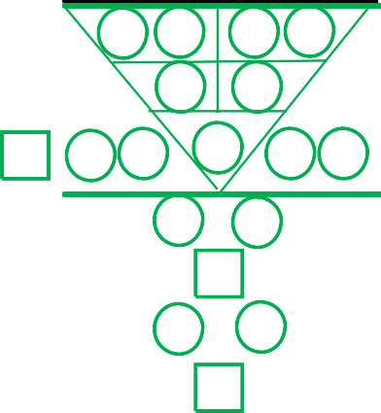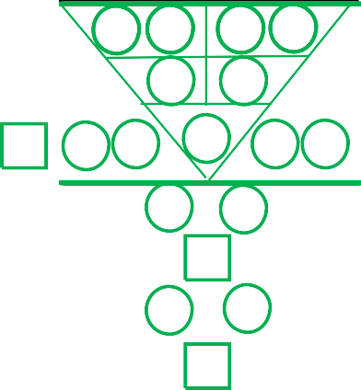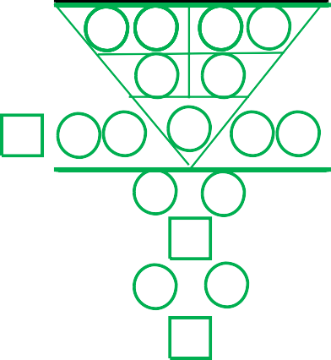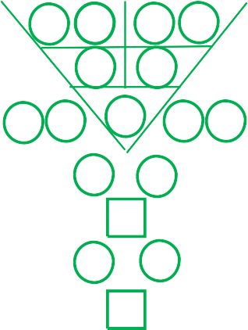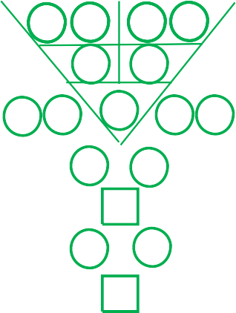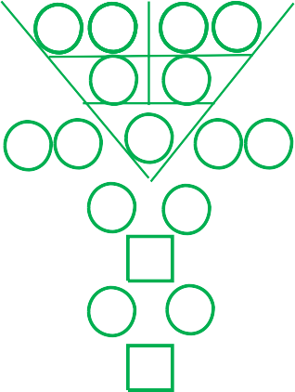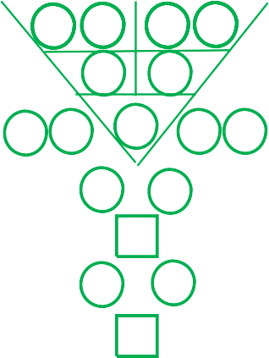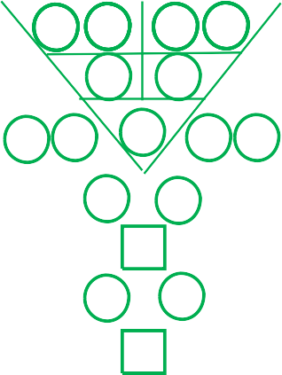

{m93l}

{m73l}

{m73r}

{m83l}

{m83r}

{m93r}

**{first_name} {last_name} 9年个人展望图表**

**{py31} {py32} {py33} {py34}**

**{py21} {py22} {py23} {py24}**

**{py11} {py12} {py13} {py14}**

**年**

**{py32} {py33} {py34}**

**年**

**{py22} {py23} {py24}**

**年**

**{py12} {py13} {py14}**

|  |  |  |  |  |  |  |  |  |  |
| --- | --- | --- | --- | --- | --- | --- | --- | --- | --- |
|  | |  | | | {py11} | | {py12} | {py13} | {py14} |
| {d1} | {d2} | {mm} | | | {y1} {y2} | | | {y3} {y4} | |
|  | {p111} | | {p112} |  | | {p113} | {p114} | |  |
|  |  | | {p121} |  | | {p122} |  | |  |
| {p131} | {p132} | |  | {p133} | |  | {p134} | | {p135} |
| {p141} | | | |  | | {p142} | | | |
|  | | | | {p151} | |  | | | |
| {p161} | | | |  | | {p162} | | | |
|  | | | | {p171} | |  | | | |
|  | | | | | | | | | |

|  |  |  |  |  |  |  |  |  |  |
| --- | --- | --- | --- | --- | --- | --- | --- | --- | --- |
|  | |  | | | {py21} | | {py22} | {py23} | {py24} |
| {d1} | {d2} | {mm} | | | {y1} {y2} | | | {y3} {y4} | |
|  | {p211} | | {p212} |  | | {p213} | {p214} | |  |
|  |  | | {p221} |  | | {p222} |  | |  |
| {p231} | {p232} | |  | {p233} | |  | {p234} | | {p235} |
| {p241} | | | |  | | {p242} | | | |
|  | | | | {p251} | |  | | | |
| {p261} | | | |  | | {p262} | | | |
|  | | | | {p271} | |  | | | |
|  | | | | | | | | | |

|  |  |  |  |  |  |  |  |  |  |
| --- | --- | --- | --- | --- | --- | --- | --- | --- | --- |
|  | |  | | | {py31} {py32} | | | {py33} | {py34} |
| {d1} | {d2} | {mm} | | | {y1} {y2} | | | {y3} {y4} | |
|  | {p311} | | {p312} |  | | {p313} | {p314} | |  |
|  |  | | {p321} |  | | {p322} |  | |  |
| {p331} | {p332} | |  | {p333} | |  | {p334} | | {p335} |
|  |  | | {p341} |  | | {p342} |  | |  |
|  |  | |  | {p351} | |  |  | |  |
|  |  | | {p361} |  | | {p362} |  | |  |
|  |  | |  | {p371} | |  |  | |  |
|  | | | | | | | | | |

{p33l}

{p13l}

{p13r}

{p23l}

{p23r}

{p33r}

**{py61} {py62} {py63} {py64}**

**{py51} {py52} {py53} {py54}**

**年**

**{py62} {py63} {py64}**

**年**

**{py52} {py53} {py54}**

**{py41} {py42} {py43} {py44}**

**年**

**{py42} {py43} {py44}**

|  |  |  |  |  |  |  |  |  |  |
| --- | --- | --- | --- | --- | --- | --- | --- | --- | --- |
|  | |  | | | {py41} | | {py42} | {py43} | {py44} |
| {d1} | {d2} | {mm} | | | {y1} {y2} | | | {y3} {y4} | |
|  | {p411} | | {p412} |  | | {p413} | {p414} | |  |
|  |  | | {p421} |  | | {p422} |  | |  |
| {p431} | {p432} | |  | {p433} | |  | {p434} | | {p435} |
| {p441} | | | |  | | {p442} | | | |
|  | | | | {p451} | |  | | | |
| {p461} | | | |  | | {p462} | | | |
|  | | | | {p471} | |  | | | |
|  | | | | | | | | | |

|  |  |  |  |  |  |  |  |  |  |
| --- | --- | --- | --- | --- | --- | --- | --- | --- | --- |
|  | |  | | | {py51} | | {py52} | {py53} | {py54} |
| {d1} | {d2} | {mm} | | | {y1} {y2} | | | {y3} {y4} | |
|  | {p511} | | {p512} |  | | {p513} | {p514} | |  |
|  |  | | {p521} |  | | {p522} |  | |  |
| {p531} | {p532} | |  | {p533} | |  | {p534} | | {p535} |
| {p541} | | | |  | | {p542} | | | |
|  | | | | {p551} | |  | | | |
| {p561} | | | |  | | {p562} | | | |
|  | | | | {p571} | |  | | | |
|  | | | | | | | | | |

|  |  |  |  |  |  |  |  |  |  |
| --- | --- | --- | --- | --- | --- | --- | --- | --- | --- |
|  | |  | | | {py61} {py62} | | | {py63} | {py64} |
| {d1} | {d2} | {mm} | | | {y1} {y2} | | | {y3} {y4} | |
|  | {p611} | | {p612} |  | | {p613} | {p614} | |  |
|  |  | | {p621} |  | | {p622} |  | |  |
| {p631} | {p632} | |  | {p633} | |  | {p634} | | {p635} |
|  |  | | {p641} |  | | {p642} |  | |  |
|  |  | |  | {p651} | |  |  | |  |
|  |  | | {p661} |  | | {p662} |  | |  |
|  |  | |  | {p671} | |  |  | |  |
|  | | | | | | | | | |

{p63l}

{p43l}

{p43r}

{p53l}

{p53r}

{p63r}

**{py91} {py92} {py93} {py94}**

**{py81} {py82} {py83} {py84}**

**年**

**{py92} {py93} {py94}**

**年**

**{py82} {py83} {py84}**

**{py71} {py72} {py73} {py74}**

**年**

**{py72} {py73} {py74}**

|  |  |  |  |  |  |  |  |  |  |
| --- | --- | --- | --- | --- | --- | --- | --- | --- | --- |
|  | |  | | | {py71} | | {py72} | {py73} | {py74} |
| {d1} | {d2} | {mm} | | | {y1} {y2} | | | {y3} {y4} | |
|  | {p711} | | {p712} |  | | {p713} | {p714} | |  |
|  |  | | {p721} |  | | {p722} |  | |  |
| {p731} | {p732} | |  | {p733} | |  | {p734} | | {p735} |
| {p741} | | | |  | | {p742} | | | |
|  | | | | {p751} | |  | | | |
| {p761} | | | |  | | {p762} | | | |
|  | | | | {p771} | |  | | | |
|  | | | | | | | | | |

|  |  |  |  |  |  |  |  |  |  |
| --- | --- | --- | --- | --- | --- | --- | --- | --- | --- |
|  | |  | | | {py81} | | {py82} | {py83} | {py84} |
| {d1} | {d2} | {mm} | | | {y1} {y2} | | | {y3} {y4} | |
|  | {p811} | | {p812} |  | | {p813} | {p814} | |  |
|  |  | | {p821} |  | | {p822} |  | |  |
| {p831} | {p832} | |  | {p833} | |  | {p834} | | {p835} |
| {p841} | | | |  | | {p842} | | | |
|  | | | | {p851} | |  | | | |
| {p861} | | | |  | | {p862} | | | |
|  | | | | {p871} | |  | | | |
|  | | | | | | | | | |

|  |  |  |  |  |  |  |  |  |  |
| --- | --- | --- | --- | --- | --- | --- | --- | --- | --- |
|  | |  | | | {py91} {py92} | | | {py93} | {py94} |
| {d1} | {d2} | {mm} | | | {y1} {y2} | | | {y3} {y4} | |
|  | {p911} | | {p912} |  | | {p913} | {p914} | |  |
|  |  | | {p921} |  | | {p922} |  | |  |
| {p931} | {p932} | |  | {p933} | |  | {p934} | | {p935} |
|  |  | | {p941} |  | | {p942} |  | |  |
|  |  | |  | {p951} | |  |  | |  |
|  |  | | {p961} |  | | {p962} |  | |  |
|  |  | |  | {p971} | |  |  | |  |
|  | | | | | | | | | |



{p93l}

{p73l}

{p73r}

{p83l}

{p83r}

{p93r}



**清晰的人生旅程**

**清晰的思维和心灵是你人生必备的钥匙**，

**赋予你预测和预防未来人生旅途中的所有挑战，同时能够做出正确的决定。**

**~ 杨富渼博士 ， 荣誉哲学博士学位**

来自新加坡的杨富渼博士是天性研究学的创办人, 国际讲师和拥有培训与新加坡评估高级证书

（ACTA）资格，也是畅销书“了解数字，了解自己”一书作者。

2012年，因杰出的研究被发掘而授予亚太杰出商业专业奖。隔年2013年，获颁荣誉哲学博士学位和亚洲管理研究所之杰出研究员荣衔，以表扬他在天性与性格分析专业领域上的杰出贡献。

2014至2020年，天性研究学学院荣获多项荣耀，包括亚洲优秀企业奖，新加坡中小型企业之亚太区域奖，新加坡优秀企业奖和新加坡亚太区域杰出品牌奖。

杨富渼博士于2008年开始潜心专研性格分析。历经13年的深入探索，他花了长达70,000小时的分析研究，细读了上百篇的研究报告，结合翻阅了上千篇的研究资料和分析了十二千人后，才创办“天性研究学”。

##### UCMHP Academy Pte Ltd

**3 Irving Road, #01-09, Tai Seng Centre Singapore 369522**

**电话: (65) 6748 6279 网址:** [**cs@ucmhpacademy.com**](mailto:cs@ucmhpacademy.com)

[**www.ucmhpacademy.com**](http://www.ucmhpacademy.com) **Facebook:** [**www.facebook.com/UCMHP**](http://www.facebook.com/UCMHP)

**®**

Copyright © 2012 UCMHP Academy Pte Ltd, All Rights Reserved. Update 2021